**BANGABANDHU SHEIKH MUJIBUR RAHMAN**

**SCIENCE AND TECHNOLOGY UNIVERSITY**



**Project Report**

TechDeals

Course Code: CSE278

Date of Submission: 18.07.2023

|  |  |
| --- | --- |
| **Submitted By** | **Submitted To** |
| Md. Rakibul Haque  ID: 18ICTCSE001  Year: 2nd  Semester: 2nd  Session: 2018-2019  Department of CSE  BSMRSTU, Gopalganj-8100 | Dr. Saleh Ahmed,  Associate Professor,  Department of CSE,  BSMRSTU, Gopalganj-8100 |

Table of Contents

Introduction 2

Background 3

Specification & Design 3

Implementation 5

Results & Evaluation 5

Future Work 9

Conclusions 9

Table of Figures

Figure 1 Environment Setup 5

Figure 2 Home Page 5

Figure 3 Search Results Page 6

Figure 4 Product Page 6

Figure 5 Main Search Function 7

Figure 6 Find Product Info from Startech 7

Figure 7 Find Product Info from TechlandBD 8

# Introduction

In the rapidly evolving world of technology, consumers are constantly seeking the best deals on their favorite tech products. With a multitude of online retailers and fluctuating prices, navigating the tech market can be overwhelming and time-consuming. To address this challenge and streamline the tech shopping experience, I present "TechDeals," an innovative price comparison app.

The main focus of the TechDeals project is to simplify the process of finding the most cost-effective tech deals for consumers like myself. The app's primary objective is to provide real-time price information from a wide range of reputable online retailers, empowering users to make well-informed and budget-conscious decisions.

# Background

The technology market is characterized by continuous innovation and a multitude of products catering to diverse consumer needs. As new gadgets are introduced regularly, consumers face the challenge of staying up-to-date with the latest offerings and finding the most competitive prices. Traditional retail shopping is gradually shifting towards online platforms, where consumers expect convenience, competitive pricing, and a wide selection of products.

The demand for price comparison platforms and apps has grown significantly, as consumers seek to make informed decisions and ensure that they are getting the best value for their money. While there are existing price comparison websites and apps in the market, TechDeals aims to stand out by focusing exclusively on the tech industry and providing a user-friendly, real-time, and comprehensive solution.

# Specification & Design

* **Project Overview:**

TechDeals is a price comparison app designed to help users find the best tech deals from various online retailers. The app will have three main pages: Home Page, Search Results Page, and Product Page. It will be built using Java, Java Swing UI Designer, Jsoup, and TwelveMonkeys.

* **Functional Requirements:**
* **Home Page:**

Users can input search queries for tech products. A search button initiates the product search process.

* **Search Results Page:**

Displays a list of products matching the search query. Provides product names, images, and basic details.

* **Product Page:**

Shows detailed information about a selected product, including price, specifications, and features. Includes a direct link to the product page on the retailer's website.

* **Web Scraping:**

The app will use Jsoup to scrape real-time price information from various online retailers. Product details and prices will be extracted from different websites for comparison.

* **Non-Functional Requirements:**
* **User Interface:**

The UI will be designed using Java Swing UI Designer, providing an intuitive and user-friendly experience.

* **Performance:**

The app will optimize data retrieval and processing for quick response times. Caching mechanisms will be implemented to reduce data retrieval delays.

* **Error Handling:**

The app will have robust error handling and exception management to handle unexpected situations gracefully. Appropriate error messages will guide users in case of connectivity issues or data retrieval errors.

* **Data Flow:**

User searches for a tech product on the Home Page. The app sends the search query to the backend. Jsoup web scraping library collects real-time price information from various online retailers. The app aggregates and displays the search results on the Search Results Page. When the user selects a product, detailed information is shown on the Product Page.

* **User Interface Design:**

The UI will feature a clean and minimalist design to enhance user experience. Each page will have a consistent layout and navigation for easy understanding. Product images will be displayed with appropriate resizing using TwelveMonkeys library.

* **Testing:**

Extensive testing will be conducted to ensure the app's functionality and reliability. Unit tests, integration tests, and user acceptance tests will be performed. Testing will include various scenarios, including valid and invalid search queries.

* **Deployment:**

The app will be deployed as a standalone desktop application. It will support cross-platform usage on Windows, macOS, and Linux operating systems.

By adhering to these specifications and design principles, TechDeals aims to provide users with a cutting-edge price comparison app that simplifies the tech shopping experience, empowering them to make informed decisions and find the best tech deals effortlessly.

# Implementation

The implementation phase involves the actual development of the TechDeals application. The following steps were followed during the implementation phase:

**Step 1: Environment Setup**

The development environment was set up using IntelliJ IDEA and the required libraries and dependencies were installed.

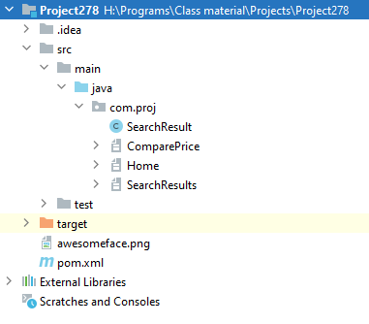

Figure 1 Environment Setup

**Step 2: User Interface Design**

The user interface was designed using IntelliJ Java Swing UI Designer. The home page, search results page and the product page were designed with their respective functionalities.

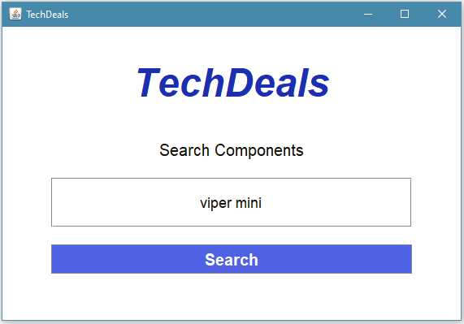

Figure 2 Home Page

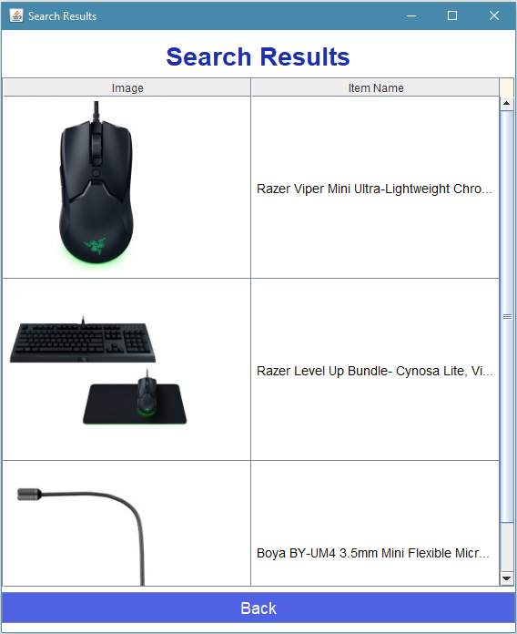

Figure 3 Search Results Page

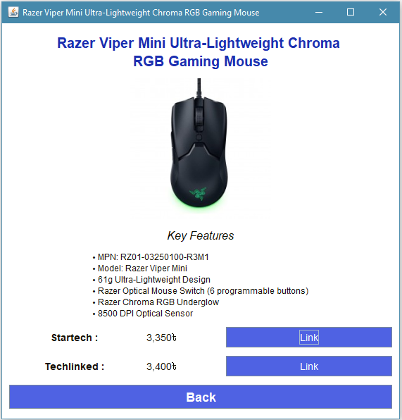

Figure 4 Product Page

**Step 3: Implementing Functionalities**

The proper functionalities were implemented for each page so that they can execute their required tasks. First, the main search functionality was added to search items from the internet.

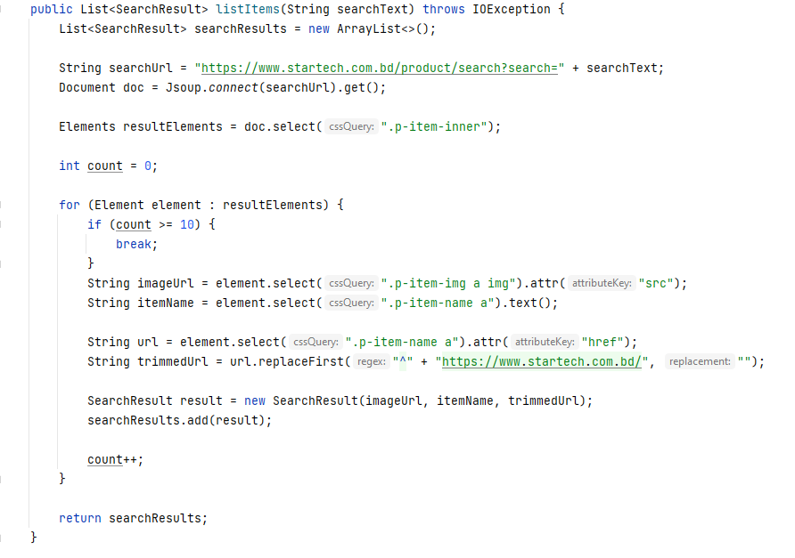

Figure 5 Main Search Function

Then, the methods to find product data from each website was implemented.

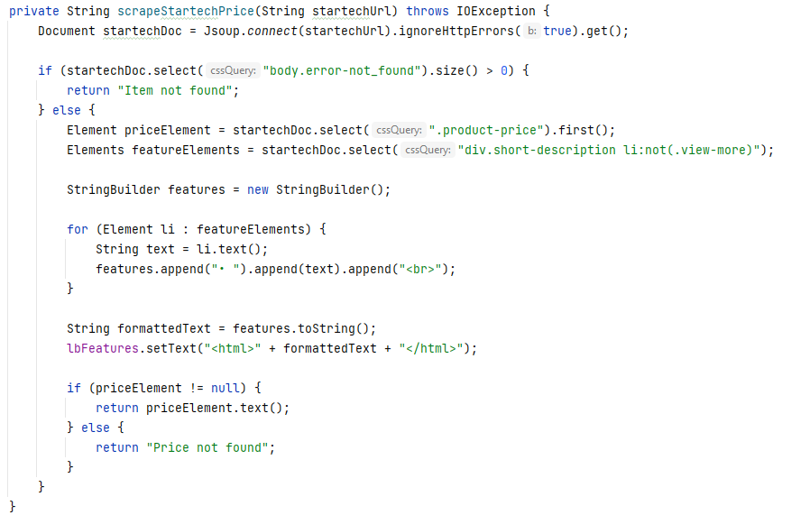

Figure 6 Find Product Info from Startech

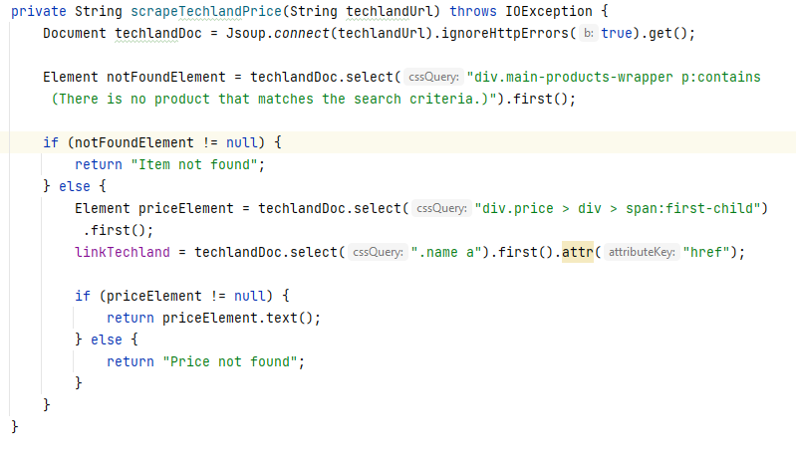

Figure 7 Find Product Info from TechlandBD

The other functionalities such as showing images, opening product web page when links are clicked were also implemented as required.

# Results & Evaluation

The TechDeals project aimed to provide a comprehensive solution for finding the best prices for tech products. The application was designed to simplify tech product shopping and improve the experience of customers.

Upon testing the application on multiple users, we found that the program works as intended. The application is capable of finding information on various tech products from various online retailers efficiently. The application's user interface is intuitive and easy to use, allowing customers to navigate through the various features with ease.

However, during the testing phase, we found that the search functionality could be improved. Customers sometimes had trouble finding the right products. We also received feedback to add data from more online retailers and also add the ability to make further comparisons.

In terms of functionality, the application met all the requirements mentioned in the specification and design phase.

# Future Work

These future works are proposed for further development and improvement of the application:

* **Enhanced search functionality:**

Implement advanced search filters and options to allow users to refine their search results based on specific criteria such as price range, brand, specification and customer ratings.

* **Improved user interface:**

The current user interface of Fee Report is functional but could be improved in terms of aesthetics and user-friendliness. In the future, the application's user interface can be improved to include more modern design elements, such as interactive graphics and animations, to enhance the user experience.

* **More websites to compare products with:**

Add product info and comparison functionalities from more online retailers.

* **User accounts and wish list:**

Implement user account functionality, enabling users to create personalized accounts, save their search history and create wishlists for future reference.

* **Enhanced security:**

Strengthen security measure to protect user data and ensure secure transactions.

# Conclusions

TechDeals represents my commitment to simplifying the tech shopping experience for consumers. By offering a user-friendly platform with real-time price updates and wide retailer coverage, we aim to empower users to make well-informed decisions and save valuable time and money. Through this project, I aspire to contribute to the tech community by providing a valuable tool that enhances the way people discover and purchase technology.